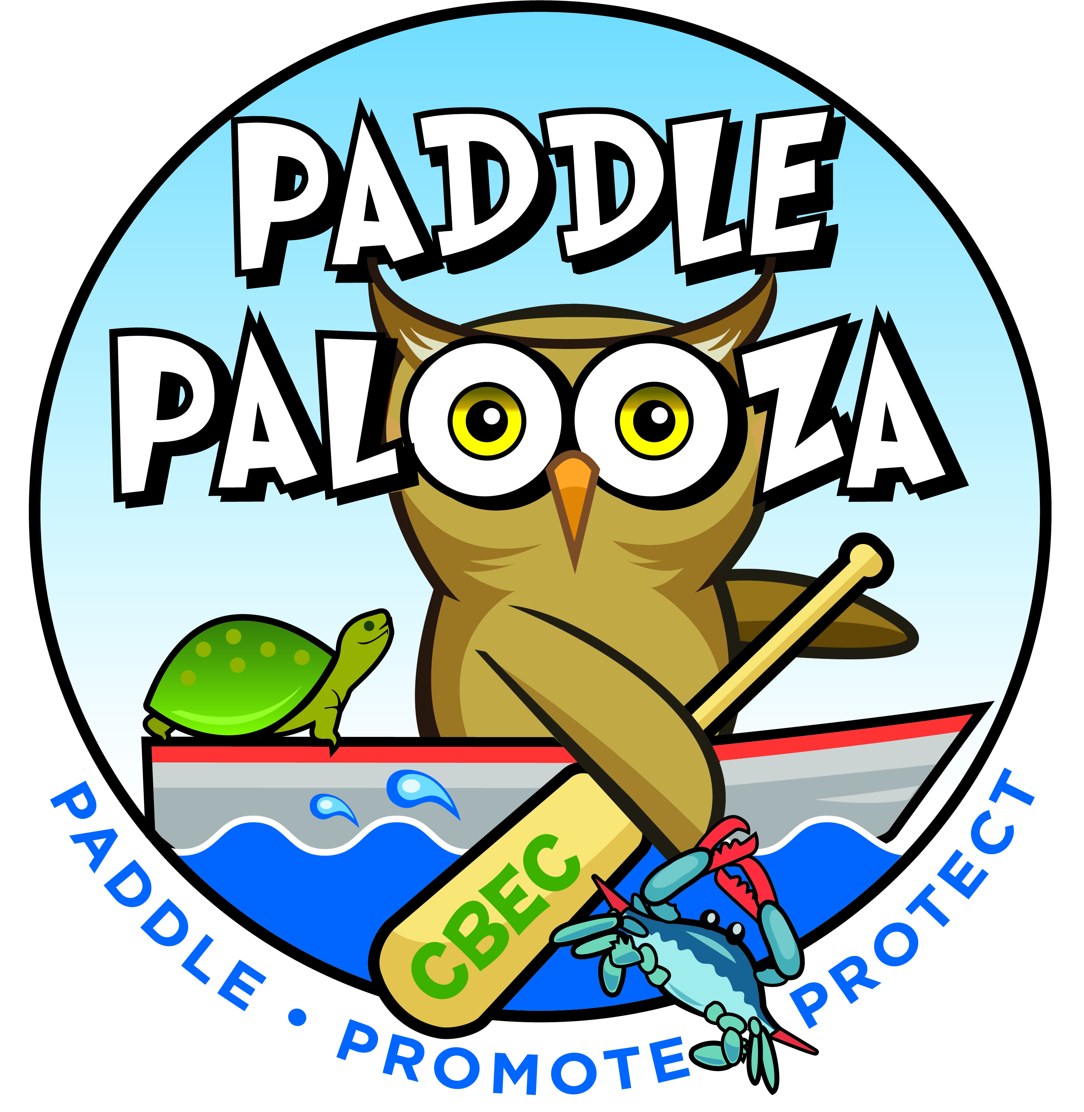

Paddlepalooza DONATION OPPPORTUNITIES
July 14th 8:00am-4:00pm
Chesapeake Bay Environmental Center

Support CBEC’s Kayak the Wetlands Education Programs!

Donations Needed:
Donated items will be used for event support. Item should be valued at $20 or more. Donated items can be picked up by a CBEC volunteer or dropped off at CBEC 600 Discovery Lane, Grasonville, MD.

Donor Recognition:
All donors will be recognized on CBEC’s website as well as the day of the event. This is great positive publicity for yourself or company!

Business Name: _______________________________________________________________
Address: _____________________________________________________________________
Contact Person:_______________________________________________________________
Phone: ________________________ Email: _______________________________________
Value of item donated: $ _______________
Item to be picked up or delivered? _________________________*Items needed by 7/13/18*
Item donated & description: ______________________________________________________ ____________________________________________________________________________
Your support is greatly appreciated! *CBEC is a 501(c) 3 organization and your donation is tax deductible to the extent allowed by law.*

Mail or drop off completed form and/or donated items to the address listed below!

