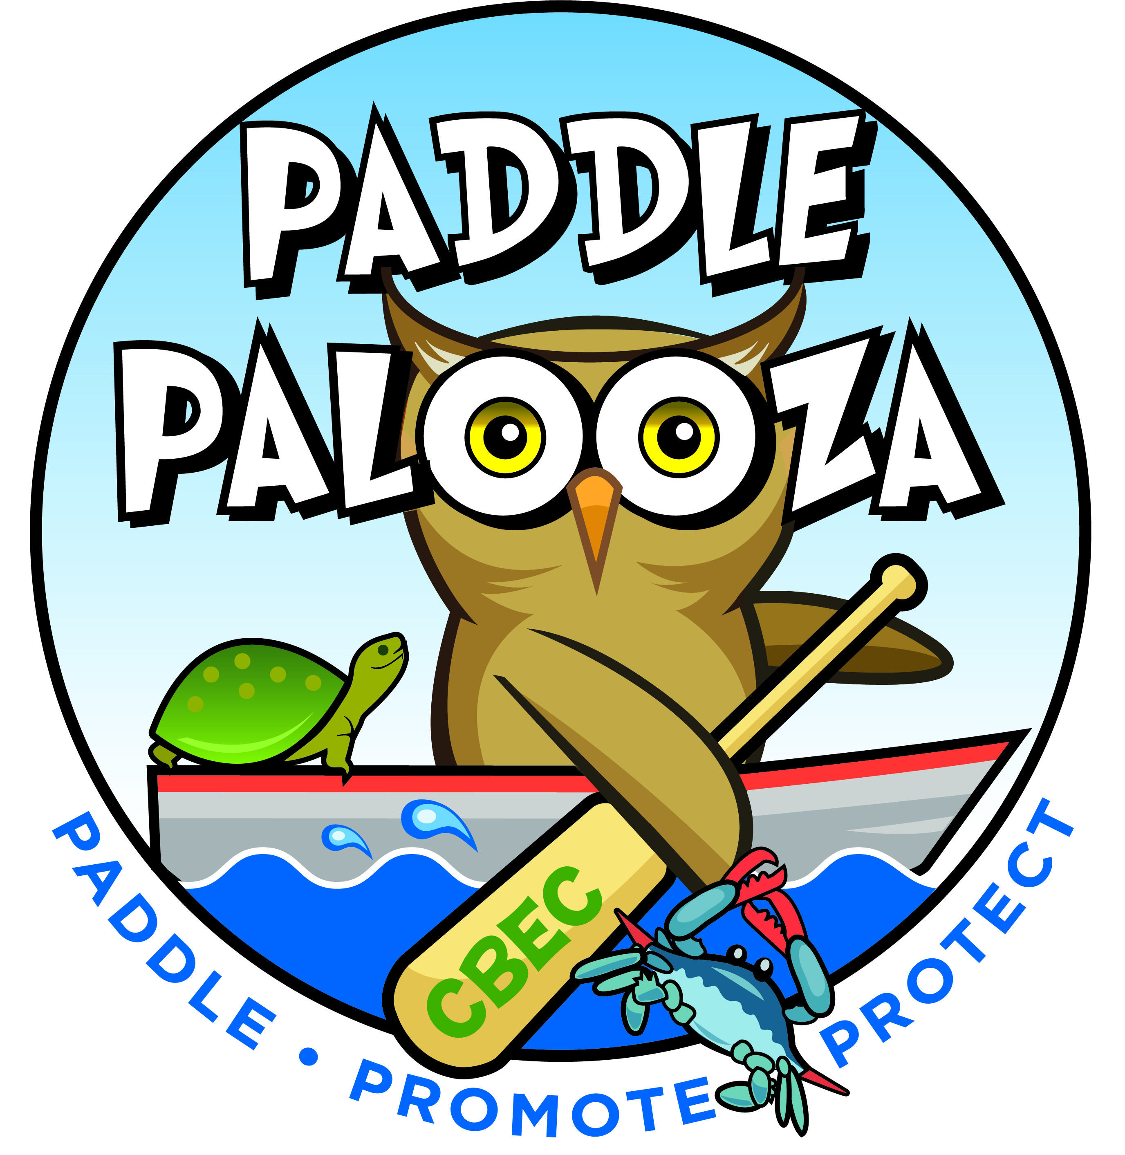
JULY 14th, 2018
Schedule:
Pre-Event Day, Friday, July 13th
- 4pm-6pm Optional Equipment Drop-Off /Check In at Start Point at CBEC (Wanuga Lane) *This location is private property and will be secure.
  - Each participant that Drops Off Personal Vessel/Check In on Friday receives 1 free raffle ticket for . Raffle will occur on Saturday, July 14th during the After Party at the Lakeside Pavilion.
  - Participants must show ID and Signed Kayak Waiver to check in!
  - All equipment can be dropped at this time : Boats, PFD’s, and Paddles
  - Participants taking this option will report directly to Parking Lot on EVENT DAY and then take a Shuttle to Start Point on Wanuga Lane ready to paddle with Bib, Event Map, Water Bottle, and Whistle in their possession. *THIS WILL HELP THE DECREASE THE WAIT TIME ON EVENT DAY!
  - Please check Paddlepalooza Event Website in case of inclement weather that would impede Friday Boat Drop off: https://www.bayrestoration.org/paddlepalooza/

Event Day, Saturday, July 14th
- 8:00am-9:30am Equipment Drop-Off and Check In at Start Point at CBEC (Wanuga Lane)
- 8:00am-9:30am Participant Transport (Between Parking Lot/Lakeside Pavilion and Start Point)
- 9:00am First Wave Safety Briefing and Start
- 10:00am Last Wave Safety Briefing and Start
- 10:30am-3pm Lakeside Pavilion Party
- 11:00am-3:00pm Live Music-What’s Her Face And the Stuff
- 2:00pm All Boats Off The Water
  - Please check Paddlepalooza Event Website in case of inclement weather that would impede Event Schedule: https://www.bayrestoration.org/paddlepalooza/
Logistics:
- Arrival:
  - Bringing Personal Vessel on Event Day:
  - Participants must show ID and Signed Waiver to Check In
-Please enter 600 Discovery Lane and then follow signs to Boat Drop Off. (This will be a left at the fork proceeding onto Wanuga Lane).
-Event Staff will be facilitating a line of cars waiting to drop off vessels at start.
-At Boat Drop Off /Start Site participants will be checking in with PHOTO ID and receiving their Bib, Boat ID Tag, Event Map, and Whistle.
-All equipment must be dropped: Boat, PFD, and Paddle
-After boat is dropped off, participants will drive to Parking Lot and take Shuttle back to Start Point ready to paddle with Bib, Event Map, Whistle, and Water Bottle.
  - Using a Vendor Vessel on Event Day:
  - Participants must show ID and Signed Waiver to Check In
-Please enter 600 Discovery Lane and follow signs to Parking Lot. (This will be a right at the fork continuing on Discovery Lane).
-After parking your car proceed to the Shuttle Stop at the Parking Lot to board the Shuttle ready to paddle with a Whistle, Water Bottle, and ID. You will Check In at Start Point to receive your Bib and your equipment at the Start Point.
- Paddle
  - Waves of 10 boats will start from a beach beginning at 9am and each consecutive wave will be 10 minutes apart…we hope to have the last wave off the beach at 10am.
  - Boats will head to the right off of the beach and follow the contour of the Peninsula staying within 100 ft. of the shoreline during the entire paddle.
  - PFD’s and Whistle must remain on body at all times
  - There are 4 safety boats marked on Event Map if you need water, snack, or assistance. They will be identified by a buoy and crew will be wearing bright orange event T-Shirts.
Keep these vessels to your left the entire course.
  - There are 7 safety kayakers spread between the safety boats…they have a neon orange T-Shirt on. Ask for help if you need it!
  - There is a beach with a port a potty at the half way point.
  - You must be past the beach by 1:15pm or you will be extracted at the beach and not able to complete the 3 mile course to the Kayak Dock. Your boat will be transported to Boat Pick Up location at Parking Lot.
- Finish/Boat Pick Up
  - The Finish and Exit Point are at the Kayak Floating Dock in Marshy Creek at the end of Marshy Creek Trail. *NOTE THAT MARSHY CREEK TRAIL WILL BE CLOSED TO PEDESTRIAN TRAFFIC…NO SPECTATORS AT FINISH. SPECTATORS ARE ALLOWED AT START POINT AND BEACH ONLY!
  - Personal Vessel Exit Procedures
    - Event Staff will aid in transporting you, your vessel, and equipment to the Boat Pick Up area located at the Parking Lot via a Truck and Kayak Trailer. *You may be asked to carry your PFD, Paddle, and Water Bottle while you walk a 5 minute distance on Marshy Creek Trail back to Parking Lot.
    - Please report to Boat Pick Up area with your Bib to claim and pick up your personal vessel. Volunteers will be there to help move it to your vehicle. Please don’t take your personal vessel without checking it out with Event Staff at the Boat Pick Up area.
    - When your personal vessel is picked up report to Lakeside Pavilion with your BIB for Event Gift, FREE BEER if 21 yrs. old or older with PHOTO ID, and festivities!
- Rented Vendor Vessel Exit Procedures
  - Event Staff will aid in transporting you and your PFD /Paddle to the Boat Pick Up area located at the Parking Lot via a Truck and Kayak Trailer. Your rented vessel will be racked at the Kayak Rack located at the end of Marshy Creek Trail. *You may be asked to carry your PFD, Paddle, and Water Bottle while you walk a 5 minute distance on Marshy Creek Trail back to Parking Lot.
  - Please report to Boat Pick Up area at the Parking Lot with your Bib to drop off your CBEC KAYAK rented PFD and Paddle. *SUP RENTED PADDLES AND PFD WILL REMAIN WITH SUP ON RACK.
  - Proceed to Lakeside Pavilion with your BIB for Event Gift, FREE BEER if 21 yrs. old or older with Photo ID, and festivities!
- Party
  - Vendors and DJ will be set up by 10am for Spectator Enjoyment: BRING CASH
    - Smoke, Rattle, and Roll will have lunch for purchase
    - Kettle Corn, Cotton Candy, and Snow Cones will be available for purchase
    - Beer Truck will be available for purchase for Spectators (Participants will have to wait and enjoy free beer till after they have finished the paddle)
    - Various other vendors will be present selling wares or activities for the kids
    - Raffle Tickets will be sold for $10 each to win a Stand Up Paddle Board valued at 1,000.
- LIVE MUSIC: What’s Her Face and The Stuff will play from 11am-3pm
- Party End Time: 4pm
- Spectators
  - Lots for spectators to enjoy while the paddlers are on the water!
  - Hiking Trails with gorgeous vistas * EXCEPT MARSHY CREEK TRAIL…WILL BE CLOSED TO HIKING.
  - BEACH is available for viewing paddlers at the halfway point
  - Birds of Prey on Display
  - DOGS ARE ONLY ALLOWED ON PROPERTY IF THEY ARE A CBEC MEMBER REGISTERED DOG AND MUST BE ON LEASH AT ALL TIMES! https://www.bayrestoration.org/dogs/
- SPONSORS and DONORS:
- Paddlepalooza Sponsors

- Sea Kayak ($500)-
- Benedict A. Andrew Post 296
- Eastern Shore Dental Care
- Log Canoe ($100)-
- VFW #7464-Grasonville ($250)
- Dick's Sporting Goods
- Shore United Bank
- AAE Photography
- Donations
- Eco Interior Maintenance $500 Entire Home Carpet Cleaning
- SAFEWATCH
- Western Auto
- George Norberg
- George and Mary Medicus
- Bryan Feock
- Sandy Reinhard
- Ken McDonald
- Karen Stansbury
- Karen Bogue
- Carla Slye
- DJ Tavis Whittington
- Cal Case

          - VOLUNTEERS:
  - This event takes 45 volunteers to safely put on!
  - Thank you to the KENT ISLAND POWER SQUANDRON and the Queen Anne’s County RADIO CLUB
  - Thank you to CBEC VOLUNTEERS!
  - Thank you to QUEEN ANNES COUNTY EMERGENCY RESPONSE TEAM

